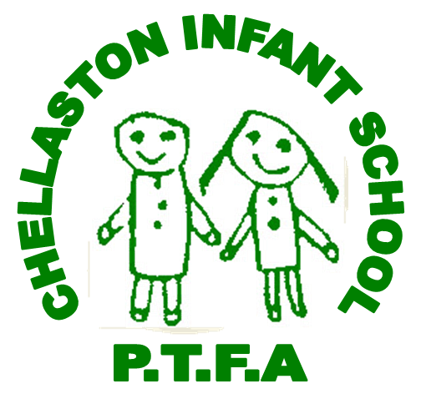
Chellaston Infant School PTFA
A summary of the PTFA officer positions:
Chair
- Work closely with treasurer and secretary to ensure association runs effectively
- Legally responsible for association
- Voting right
- Leadership of committees and setting agendas
- Welcome new members
- Sign approved minutes
- Write annual report
- Cheque signatory
- Complete risk assessments for health and safety purposes for PTFA events

Vice Chair
- To work closely with the chair, treasurer and secretary
- To assist the chair with the above responsibilities
Secretary
- Effective communication with committee members, PTA and School
- Correspondence
- Agenda preparation
- Meeting attendance
- Meeting notes and minutes
- Legally responsible
- Voting rights
- Meeting/Event arrangements
- Cheque signatory
- Annual report with Chair
Treasurer
- Record all income and expenditure
- Financial reports to committee meetings
- Operation of a bank account and bank reconciliations
- Cash counting, handling, banking and event floats
- Annual accounts
- Charity regulations and gift aid
- Legally responsible
- Voting rights
- Cheque signatory
- Complete risk assessments for health and safety purposes for PTFA
Ordinary member
- Voting right
- Work alongside 3 officers in PTA work
Volunteers/Helpers
- Attend committee meetings
- No voting rights

